**Extraction: Separation of Benzoic Acid and Phenanthrene**

**Introduction**

The main purpose of this lab experiment is to separate benzoic acid and phenanthrene and extract them. The theory behind extraction is that it is a process and technique used by many chemists to a remove a compound from a solid or liquid mixture by using a solvent. By using a solvent, the compounds in the mixtures form liquid layers according to their solubility of each of the components in the layers. In addition, in a chemically active extraction, one of the compounds is chemically altered to change the solubility characteristics in order to create distinguished layers. Often, the way to do that is to make one of them either acidic or basic. A more general way of looking at the layers would be like the layers that are formed when water and liquid are added together. Thus, two layers would be formed in this experiment, the more organic layer would be like “oil” and the more soluble in the aqueous layer would be like “water”. In this experiment, the solvent would be methylene chloride, as under neutral conditions, both compounds (benzoic acid and Phenenthrene) are soluble in it.

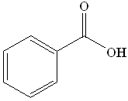 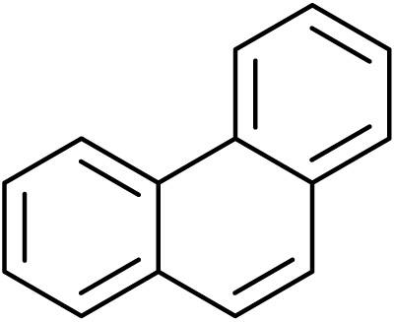

Phenanthrene

Benzoic Acid

Due to this, the mixture would be treated with an aqueous base that will allow the benzoic acid to be deprotonated and the form a water-soluble salt. If benzoic acid is a water-soluble salt, then it is more soluble in the aqueous layer than the organic layer.

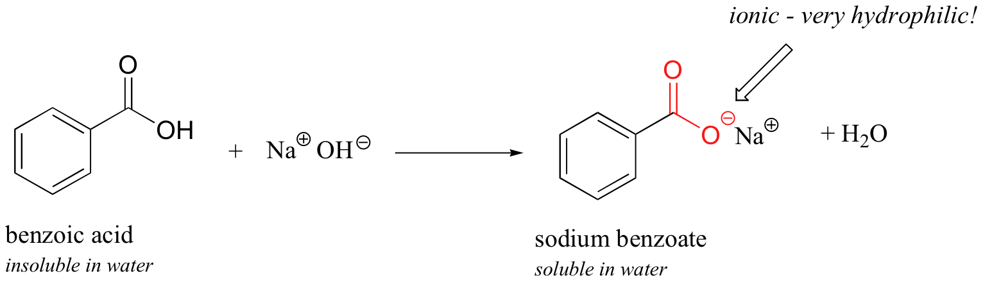

**Data of Physical Data and Hazards**

|  |  |  |  |  |  |
| --- | --- | --- | --- | --- | --- |
| **Chemical Formula & Name** | **Molecular Weight (g/mol)** | **Melting Point (C)** | **Boiling Point (C)** | **Density (g/cm3)** | **Hazards** |
| *Benzoic Acid* | 122.12 | 122.41 | 249.2 | 1.27 | Irritant |
| *Phenanthrene* | 178.23 | 101 | 340.0 | 1.18 | Moderate health hazard |
| *Methylene Chloride* | 84.93 | -96.7 | 39.6 | 1.33 | Harmful |
| *Sodium Sulfate* | 142.04 | 884 | 1429 | 2.66 | Irritant |

*Sources: Handbook for Organic Chemistry,* ***CRC Handbook of Chemistry and Physics*** *(especially Section C: "Physical Constants of Organic Compounds" ), available at the information desk in the Science Library (in Norlin) and in the Organic Chemistry Stockroom.*

***Safety Precautions***

*Hydrochloric Acid and Sodium Hydroxide solutions may cause burns or irritation when and if they are in contact with your skin for a prolonged period. Gloves and protective clothing have to be worn at all times during this experiment.*

*Phenanthrene and methylene chloride are moderate health hazard, although gloves and protective clothing should still be worn at all times.*

*Extra care and being precise is needed for this lab because a large volume of CO2 is being produced in this lab as well.*

*While shaking or mixing the solutes and solvents, constantly release pressure, if not it could cause blowout of the stopcock and the hazardous chemicals.*

**Wastes**

*Aqueous Wastes:* Aqueous filtrates and any unused acids or bases.

*Solid Chemical Wastes:* Used drying agents, pipets, filter papers, and weigh papers in small white buckets in the center of the lab

**Procedure**

1. Gather the following glassware: separatory funnel, ring clamp, ring stand, graduated cylinder, beaker, Erlenmeyer flask, stemmed funnel, stopper for the separatory funnel.
2. Clamp the separatory funnel with a ring clamp on a ringstand.
   1. Make sure the stopcock of the separatory funnel is closed
3. Weigh 0.5g of Benzoic acid: phenanthrene mixture (1:1 ratio by weight).
   1. Record the weight to the nearest 0.01g in your data
   2. Place it in a beaker
4. Get 10ml of methylene chloride (dichloromethane, CH2Cl2)
   1. Place it in the beaker with benzoic acid: phenanthrene mixture
   2. Swirl it until properly dissolved.
5. Place a stemmed funnel in the neck of the separatory funnel.
6. Transfer the mixture to the separatory funnel through the stemmed funnel.
   1. Make sure that the total volume in the separatory funnel to not exceed ¾ of the funnel volume
7. Place the stopper in the neck of the separatory funnel instead of the stemmed funnel.
8. Rock the separatory funnel, once, gently.
   1. Make sure that the stopcock is closed before rocking it
9. Point the stem up and slowly open the stopcock to release pressure. Close the stopcock back after releasing the pressure
10. Shake the funnel for a few seconds and the release the pressure by following the previous step. Do this a couple of times, an approximate of 30 seconds of shaking should suffice as the solutes will come to equilibrium between the two solvents.
11. You have to frequently release the pressure as if there is too much pressure, which can cause the stopcock and the hazardous chemicals to blow out.
12. At this point, you should be placing the separatory funnel back into the ring clamp and let it sit for a while until you see the formation of two different layers.
13. After seeing the two layers, take out the stopper from the separatory funnel and then place an Erlenmeyer Flask under the funnel.
14. Slowly open the stopcock and release the lower layer into the Erlenmeyer Flask, make sure to only release the lower layer, so extra caution and time should be taken in this step.
15. Take the upper layer out and place it in another Erlenmeyer flask, and label it. Make sure you take the upper layer out through the top of the separatory funnel.
16. Extract the organic layer, methylene chloride solution, two times with 5ml (each) of 1M NaOH(aq).
17. Combine the remaining two aqueous layers and add 1M of HCl to acidify them.
    1. Label them with the blue litmus paper, indicating acidity.
    2. A white solid should precipitate from the solution as the acidification procedure proceeds.
18. Cool the solution in an ice bath.
19. Now, a vacuum filtration (suction filtration) is needed to collect the precipitate. Thus, gather the following materials: Ring clamp, ring stand, and thick walled tube. And the following glassware: Buchner funnel/ Hirsch funnel, filter flask/side-arm flask/vacuum flask.
20. Clamp the vacuum flask to the ring stand. Place the Buchner funnel on top of the neck of the flask. Attach the heavy walled tubing to the side arm flask. Connect the tube to the vacuum system (diaphragm pump)
21. Turn on the vacuum pump.
    1. Make sure that the paper is secure on the filter, and air is being drawn through the paper.
    2. If the filter doesn’t seal it well then when the vacuum is applied, a small amount of water or solvent can help sealing prior to filtering.
22. Pour the mixture onto the filtered paper.
23. The vacuum pump should rapidly drain all the liquid away and you should only be left with the precipitate on the paper.
24. Wash the precipitate on the filter paper with a small amount of cold water.
25. Allow it to dry and then determine the weight and the melting point of this compound.
26. Now, the organic solution needs to be dried over anhydrous sodium sulfate.
27. Add a small amount of the drying agent, sodium sulfate, into the organic solution.
28. Swirl the solution, by any chance if you see it clumped together, and then you should add more of the drying agent, sodium sulfate.
29. Continue swirling and observing the solution for approximately 5-15 minutes. Keep adding the drying agent until a fresh addition no longer forms clumps in the solution
30. Now decanting. Pour the solution into another flask; leave the unwanted drying agent behind.
    1. A glass rod could possibly help in this transfer
    2. A Pasteur pipet could be used for small amounts that are left.
31. Take the solvent, methylene chloride, and place it in a side-arm flask and remove it under reduced pressure, the vacuum procedure.
32. Determine the weight and melting point of the solid that remains when all the methylene chloride has been evaporated.